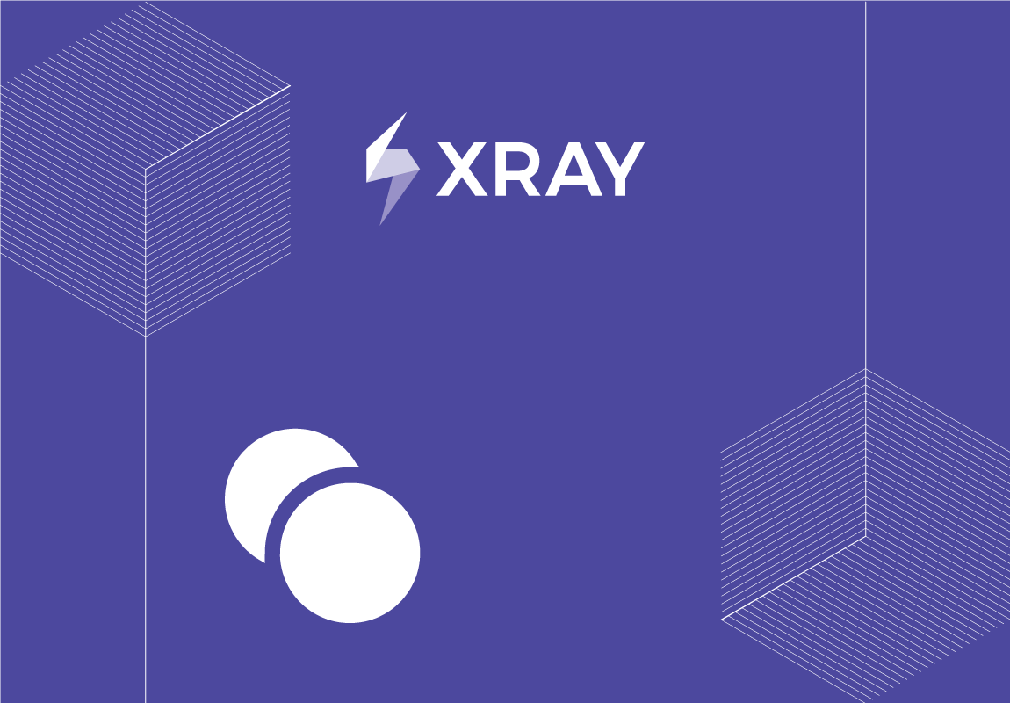

|  |
| --- |
|  |
| |  | | --- | | TEST SET  [Test Plan] Disable Edit & Upload NPWP di Extend customer  Project Name: [TCM] SINGLE ID TSO - TDMS  Issue: [TSITT-2](https://astraapps.astra.co.id/jira-software/browse/TSITT-2)  Prepared By: Naufal Zhafran Albaqi  CONFIDENTIAL | | Document Date: 6/1/2024 | |

**TABLE OF CONTENTS**

1. Introduction 4

1.1. Document Overview 4

1.2. Test Set Status 4

1.3. Test Set Description 4

2. Tests 5

2.1. Test TTDMS-13691 5

2.1.1. Test Summary 5

2.1.2. Test Description 5

2.1.3. Pre-Condition(s) 5

2.1.4. Requirement(s) linked with this test 5

2.1.5. Test Procedure 5

2.2. Test TTDMS-13692 5

2.2.1. Test Summary 5

2.2.2. Test Description 5

2.2.3. Pre-Condition(s) 5

2.2.4. Requirement(s) linked with this test 6

2.2.5. Test Procedure 6

2.3. Test TTDMS-13693 6

2.3.1. Test Summary 6

2.3.2. Test Description 6

2.3.3. Pre-Condition(s) 6

2.3.4. Requirement(s) linked with this test 6

2.3.5. Test Procedure 6

2.4. Test TTDMS-13694 7

2.4.1. Test Summary 7

2.4.2. Test Description 7

2.4.3. Pre-Condition(s) 7

2.4.4. Requirement(s) linked with this test 7

2.4.5. Test Procedure 7

2.5. Test TTDMS-13695 7

2.5.1. Test Summary 7

2.5.2. Test Description 7

2.5.3. Pre-Condition(s) 7

2.5.4. Requirement(s) linked with this test 7

2.5.5. Test Procedure 8

2.6. Test TTDMS-13696 8

2.6.1. Test Summary 8

2.6.2. Test Description 8

2.6.3. Pre-Condition(s) 8

2.6.4. Requirement(s) linked with this test 8

2.6.5. Test Procedure 8

2.7. Test TTDMS-13697 9

2.7.1. Test Summary 9

2.7.2. Test Description 9

2.7.3. Pre-Condition(s) 9

2.7.4. Requirement(s) linked with this test 9

2.7.5. Test Procedure 9

2.8. Test TTDMS-13698 9

2.8.1. Test Summary 9

2.8.2. Test Description 9

2.8.3. Pre-Condition(s) 9

2.8.4. Requirement(s) linked with this test 9

2.8.5. Test Procedure 10

3. Appendix A: Approval 11

# Introduction

## Document Overview

This Test Report provides a summary of a test set. This document has been generated automatically from the test management platform.

## Test Set Status

## Test Set Description

# Tests

## Test TTDMS-13691

### Test Summary

Sebagai Frontliner, saya tidak dapat melakukan proses ubah data NPWP dan proses upload NPWP pada menu master extend customer (Customer Retail)

### Test Description

### Pre-Condition(s)

None

### Requirement(s) linked with this test

TTDMS-13691 is associated with 0 Requirements.

### Test Procedure

This Manual Test has 4 Steps

|  |  |  |  |
| --- | --- | --- | --- |
|  | Action | Data | Expected Result |

|  |  |  |  |
| --- | --- | --- | --- |
| 1 | Login TDMS |  | Berhasil Login TDMS |

|  |  |  |  |
| --- | --- | --- | --- |
| 2 | Masuk kedalam menu service --> master --> customer --> maintaine customer |  | berhasil masuk ke menu maintaine customer |

|  |  |  |  |
| --- | --- | --- | --- |
| 3 | Pilih customer retail dengan title MR/MS |  | berhasil memilih customer retail |

|  |  |  |  |
| --- | --- | --- | --- |
| 4 | Masuk Kedalam menu extend customer verifikasi data NPWP |  | tidak dapat melakukan proses ubah data NPWP dan proses upload NPWP |

## Test TTDMS-13692

### Test Summary

Sebagai Frontliner, saya tidak dapat melakukan proses ubah data NPWP dan proses upload NPWP pada menu master extend customer (Customer Fleet)

### Test Description

### Pre-Condition(s)

None

### Requirement(s) linked with this test

TTDMS-13692 is associated with 0 Requirements.

### Test Procedure

This Manual Test has 4 Steps

|  |  |  |  |
| --- | --- | --- | --- |
|  | Action | Data | Expected Result |

|  |  |  |  |
| --- | --- | --- | --- |
| 1 | Login TDMS |  | Berhasil Login TDMS |

|  |  |  |  |
| --- | --- | --- | --- |
| 2 | Masuk kedalam menu service --> master --> customer --> maintaine customer |  | berhasil masuk ke menu maintaine customer |

|  |  |  |  |
| --- | --- | --- | --- |
| 3 | Pilih customer retail dengan title company |  | berhasil memilih customer fleet |

|  |  |  |  |
| --- | --- | --- | --- |
| 4 | Masuk Kedalam menu extend customer verifikasi data NPWP |  | tidak dapat melakukan proses ubah data NPWP dan proses upload NPWP |

## Test TTDMS-13693

### Test Summary

Sebagai ADH (yang memiliki otorisasi) saya dapat melakukan proses upload NPWP pada menu master extend customer (Customer Retail)

### Test Description

### Pre-Condition(s)

None

### Requirement(s) linked with this test

TTDMS-13693 is associated with 0 Requirements.

### Test Procedure

This Manual Test has 4 Steps

|  |  |  |  |
| --- | --- | --- | --- |
|  | Action | Data | Expected Result |

|  |  |  |  |
| --- | --- | --- | --- |
| 1 | Login TDMS |  | Berhasil Login TDMS |

|  |  |  |  |
| --- | --- | --- | --- |
| 2 | Masuk kedalam menu service --> master --> customer --> maintaine customer |  | berhasil masuk ke menu maintaine customer |

|  |  |  |  |
| --- | --- | --- | --- |
| 3 | Pilih customer retail dengan title MR/MS |  | berhasil memilih customer retail |

|  |  |  |  |
| --- | --- | --- | --- |
| 4 | Masuk Kedalam menu extend customer verifikasi data NPWP |  | dapat melakukan proses ubah data NPWP dan proses upload NPWP |

## Test TTDMS-13694

### Test Summary

Sebagai ADH (yang memiliki otorisasi) saya dapat melakukan proses upload NPWP pada menu master extend customer (Customer Fleet)

### Test Description

### Pre-Condition(s)

None

### Requirement(s) linked with this test

TTDMS-13694 is associated with 0 Requirements.

### Test Procedure

This Manual Test has 4 Steps

|  |  |  |  |
| --- | --- | --- | --- |
|  | Action | Data | Expected Result |

|  |  |  |  |
| --- | --- | --- | --- |
| 1 | Login TDMS |  | Berhasil Login TDMS |

|  |  |  |  |
| --- | --- | --- | --- |
| 2 | Masuk kedalam menu service --> master --> customer --> maintaine customer |  | berhasil masuk ke menu maintaine customer |

|  |  |  |  |
| --- | --- | --- | --- |
| 3 | Pilih customer retail dengan title company |  | berhasil memilih customer fleet |

|  |  |  |  |
| --- | --- | --- | --- |
| 4 | Masuk Kedalam menu extend customer verifikasi data NPWP |  | dapat melakukan proses ubah data NPWP dan proses upload NPWP |

## Test TTDMS-13695

### Test Summary

Sebagai Frontliner, saya tidak dapat melakukan proses ubah data NPWP dan proses upload NPWP pada menu cockpit extend customer (Customer Retail)

### Test Description

### Pre-Condition(s)

None

### Requirement(s) linked with this test

TTDMS-13695 is associated with 0 Requirements.

### Test Procedure

This Manual Test has 4 Steps

|  |  |  |  |
| --- | --- | --- | --- |
|  | Action | Data | Expected Result |

|  |  |  |  |
| --- | --- | --- | --- |
| 1 | Login TDMS |  | Berhasil Login TDMS |

|  |  |  |  |
| --- | --- | --- | --- |
| 2 | Masuk kedalam menu service --> service front end --> cockpit screen |  | berhasil masuk ke menu cockpit screen |

|  |  |  |  |
| --- | --- | --- | --- |
| 3 | Pilih customer retail dengan title MR/MS |  | berhasil memilih customer retail |

|  |  |  |  |
| --- | --- | --- | --- |
| 4 | Masuk Kedalam menu extend customer verifikasi data NPWP |  | tidak dapat melakukan proses ubah data NPWP dan proses upload NPWP |

## Test TTDMS-13696

### Test Summary

Sebagai Frontliner, saya tidak dapat melakukan proses ubah data NPWP dan proses upload NPWP pada menu cockpit extend customer (Customer Fleet))

### Test Description

### Pre-Condition(s)

None

### Requirement(s) linked with this test

TTDMS-13696 is associated with 0 Requirements.

### Test Procedure

This Manual Test has 4 Steps

|  |  |  |  |
| --- | --- | --- | --- |
|  | Action | Data | Expected Result |

|  |  |  |  |
| --- | --- | --- | --- |
| 1 | Login TDMS |  | Berhasil Login TDMS |

|  |  |  |  |
| --- | --- | --- | --- |
| 2 | Masuk kedalam menu service --> service front end --> cockpit screen |  | berhasil masuk ke menu cockpit screen |

|  |  |  |  |
| --- | --- | --- | --- |
| 3 | Pilih customer retail dengan title Company |  | berhasil memilih customer fleet |

|  |  |  |  |
| --- | --- | --- | --- |
| 4 | Masuk Kedalam menu extend customer verifikasi data NPWP |  | tidak dapat melakukan proses ubah data NPWP dan proses upload NPWP |

## Test TTDMS-13697

### Test Summary

Sebagai ADH (yang memiliki otorisasi) saya dapat melakukan proses upload NPWP pada menu cockpit extend customer (Customer Retail)

### Test Description

### Pre-Condition(s)

None

### Requirement(s) linked with this test

TTDMS-13697 is associated with 0 Requirements.

### Test Procedure

This Manual Test has 4 Steps

|  |  |  |  |
| --- | --- | --- | --- |
|  | Action | Data | Expected Result |

|  |  |  |  |
| --- | --- | --- | --- |
| 1 | Login TDMS |  | Berhasil Login TDMS |

|  |  |  |  |
| --- | --- | --- | --- |
| 2 | Masuk kedalam menu service --> service front end --> cockpit screen |  | berhasil masuk ke menu cockpit screen |

|  |  |  |  |
| --- | --- | --- | --- |
| 3 | Pilih customer retail dengan title MR/MS |  | berhasil memilih customer retail |

|  |  |  |  |
| --- | --- | --- | --- |
| 4 | Masuk Kedalam menu extend customer verifikasi data NPWP |  | dapat melakukan proses ubah data NPWP dan proses upload NPWP |

## Test TTDMS-13698

### Test Summary

Sebagai ADH (yang memiliki otorisasi) saya dapat melakukan proses upload NPWP pada menu cockpit extend customer (Customer Fleet))

### Test Description

### Pre-Condition(s)

None

### Requirement(s) linked with this test

TTDMS-13698 is associated with 0 Requirements.

### Test Procedure

This Manual Test has 4 Steps

|  |  |  |  |
| --- | --- | --- | --- |
|  | Action | Data | Expected Result |

|  |  |  |  |
| --- | --- | --- | --- |
| 1 | Login TDMS |  | Berhasil Login TDMS |

|  |  |  |  |
| --- | --- | --- | --- |
| 2 | Masuk kedalam menu service --> service front end --> cockpit screen |  | berhasil masuk ke menu cockpit screen |

|  |  |  |  |
| --- | --- | --- | --- |
| 3 | Pilih customer retail dengan title Company |  | berhasil memilih customer fleet |

|  |  |  |  |
| --- | --- | --- | --- |
| 4 | Masuk Kedalam menu extend customer verifikasi data NPWP |  | dapat melakukan proses ubah data NPWP dan proses upload NPWP |

# Appendix A: Approval

The undersigned acknowledge they have reviewed the **Test Set** and agree with the approach it presents. Changes to this **Test Set** will be coordinated with and approved by the undersigned or their designated representatives.

|  |  |  |  |
| --- | --- | --- | --- |
| Signature: |  | Date: |  |
| Print Name: |  |  |  |
| Title: |  |  |  |
| Role: |  |  |  |